Aug 8 2025 BDBP106: Linux and Python programming Lab 7 Ankita Bose, PhD

(1) The apropos command allows you to search the system’s manual pages for commands that match a specific task or keyword. This is particularly useful when you need to find a command that performs a specific task but you don’t know the name of the command. Try the following and display the output in your lab document.
(i) apropos "search for files"
(ii) apropos "list directory contents". Another way to get the same output is apropos "^list.*directory" (note the use of wildcards here).
The ^ denotes that there is no other character before the word ‘list’ in the search.
(iii) apropos "file compress"
(iv) apropos "file.*copy$" (The $ denotes that there is no character to be searched after the word ‘copy’
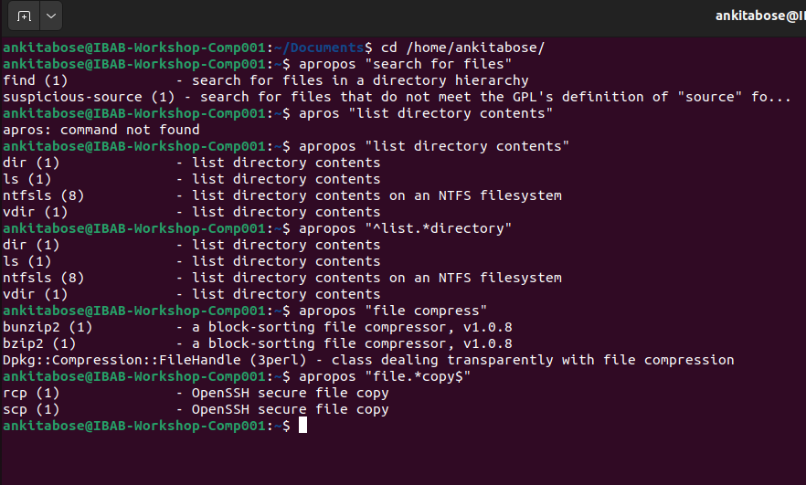
Come up with 3 more keywords/phrases that you can try for this command and got
meaningful output (show the screenshots of all your outputs)

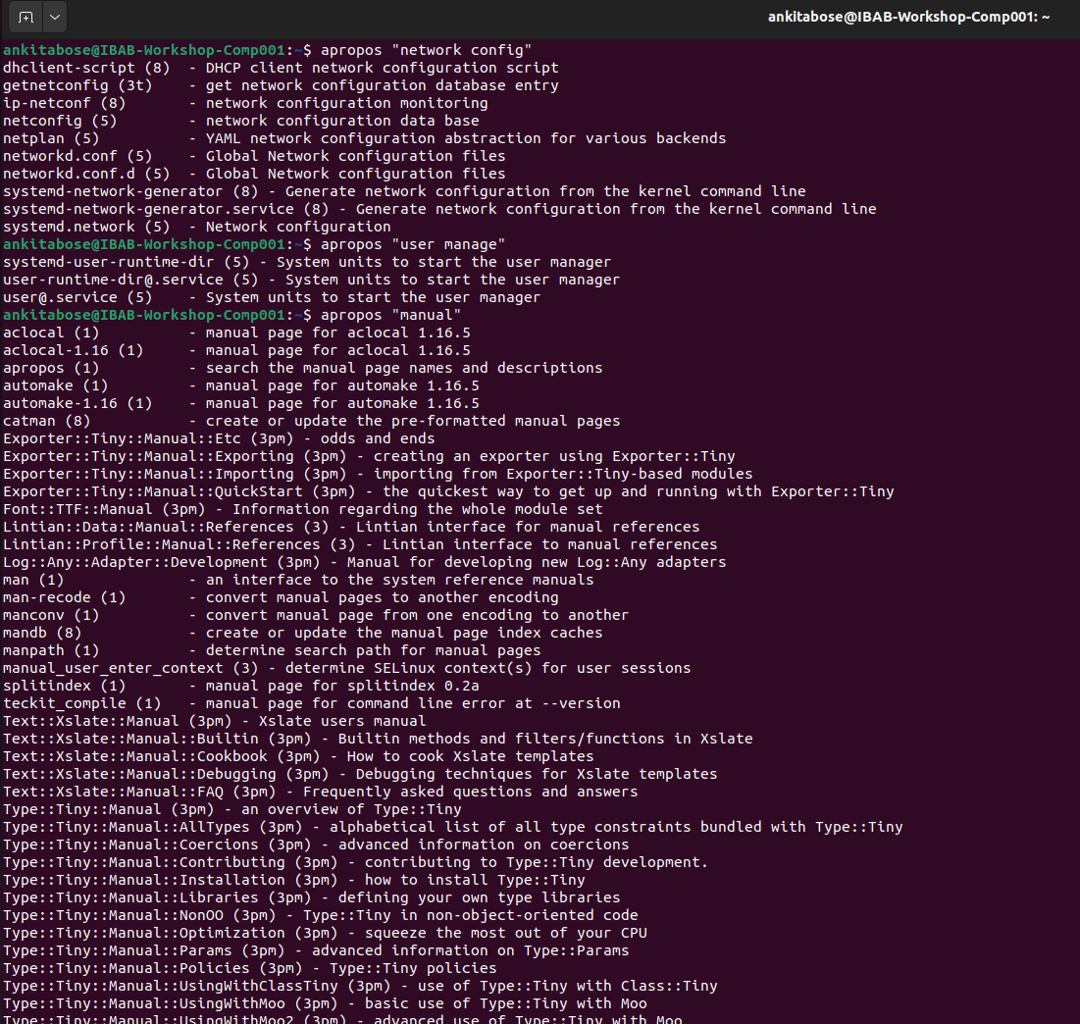

(2) File permisisons. Try the following exercises and explain the output in your work.
(i) touch newfile followed by ls -al newfile. Describe the permissions set for the user, group and everyone else.
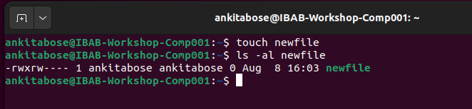
The permission for user is : rwx (can read and write file as well as execute it)
The permission for group is rw- (can only read and write file)
The permission for others is that --- (can do none)

(ii) Print the output of umask command. Explain what is the actual level of default
permission based on this output for a file, and for a directory
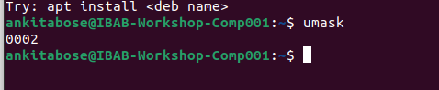
The actual default permission for this file is 664 which is a result of subtraction of the umask value of this file with the default value of 666 which is for all the possible permissions for a file.

(iii) Create a new file in your Lab7 directory and print and explain the current per-
missions for the file. Write down the octal values for the user, group and everyone
else
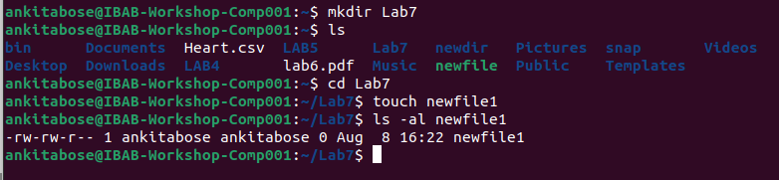
The actual default permission for this file is 664 which is a result of subtraction of the umask value of this file with the default value of 666 which is for all the possible permissions for a file.
But here the octal values for user, group and everyone else is 6, 6 and 4 respectively.

(iv) Create a new directory in your Lab7 directory and print and and explain the current
permissions for the file. Write down the octal values for the user, group and everyone
else.
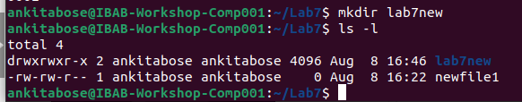

The octal values for the user, group and everyone else is 7, 7 and 5 respectively. The permission for the user is it can be read, write and execute. Same for the group but everyone else can only read and execute.

v) Copy the new file from above to the new directory and list the permissions of the
file inside the directory. Is it the same as the file outside the directory? What does
this tell you about the copying action?
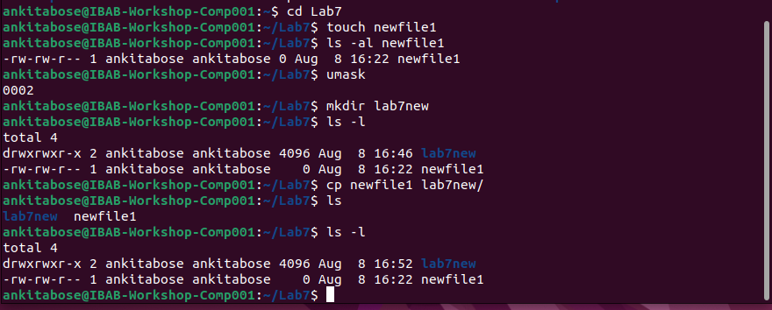
The octal values for the user, group and everyone else is 7, 7 and 5 respectively. The permission for the user is it can be read, write and execute. Same for the group but everyone else can only read and execute. Hence, the copying action on a file from one directory to another directory does not change the permissions.

(vi) Change the permissions of the directory such that it is only readable and writable
by the user and the group, and only readable by everyone else. What happens to
the permissions of the file inside the directory? Does it inherit the new permissions
you just set? What are the new octal values for the directory permissions?

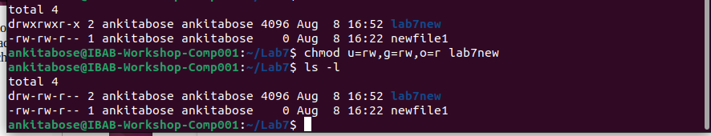
The permissions inside the directory changes as the command given but the file permission inside the directory doesnt inherit it. The new octal values for the directory permission is 664.

(vii) Move the above-created new file to the new directory under a different name. Does
the moving action change the file permissions?
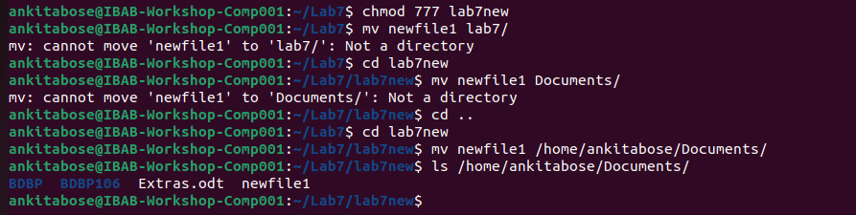
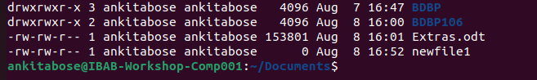
No, the moving action doesnt change the file permission

